ImageJ - CAM Application Note

1) Intelligent scans with ImageJ and the Leica CAM interface
1.1) Principle
High content imaging at high resolution can quickly generate an overwhelming amount of data and require a prohibitive acquisition time. This is especially true for 3D multispectral scans which are becoming routine work in life science. Fortunately, only a small fraction of the information acquired is usually useful to the experimenter, often interested in inspecting some sparsely spread objects or rare events. The acquisition can consequently typically be re-organized in two scans: (1) a primary scan covering a large area of the sample at the lowest resolution allowing the detection of the objects or events of interest, (2) a secondary scan with the optimal settings and fields of view centered on the positions of interest. We developed a suite of ImageJ macros enabling such dual scan (fixed and live samples, tiled fields and sequential block processing). The macros can send commands to a Leica microscope through the CAM interface (Leica Matrix HCS-A add-on module) or to any microscope controlled by Micro-manager. In this last case Micro-manager runs a custom Beanshell script. The macros are written in a modular way so that the image analysis function in charge of the objects/events detection can be easily adapted to any application.
An example application
In this application the user is interested in acquiring a large number of high resolution images of structures known as glomeruli from a GFP labeled section of a mouse kidney (figure 1).
An option is to acquire the whole region of the section by creating a large high resolution 3D mosaic but the scan runtime and the quantity of unnecessary data that would be generated is clearly unproductive.
Another option is that the user performs several scans each time moving the stage position so that the view is centered on the structures of interest. This solution is efficient in terms of the amount of data generated but it is a tedious task to perform and it requires the presence of the user at the microscope.
The solution we propose is to first acquire a low resolution map of the sample (regular grid of low resolution views tiling the sample) in the z plane detected by the autofocus. Then the positions of the targets of interest are automatically spotted on this map (automatic image analysis). Finally these positions are uploaded to the microscope software so that it sequentially acquires high resolution, possibly multiple channels, 3D stacks centered on the positions (secondary scan). This sequence is illustrated in figure 1.

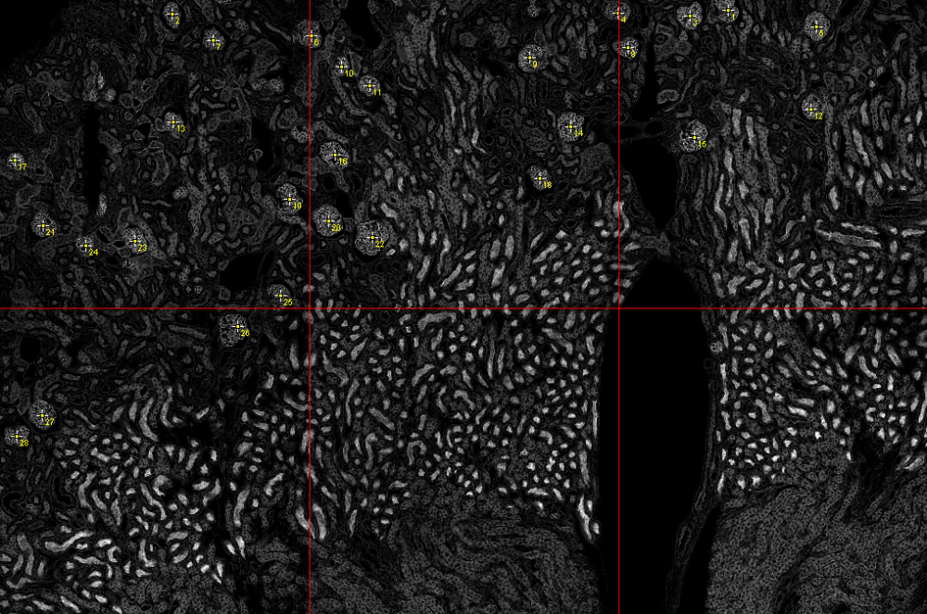
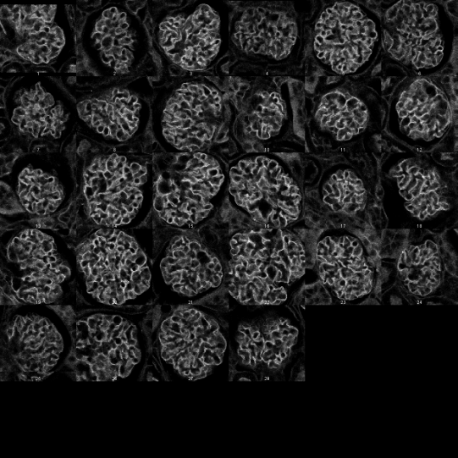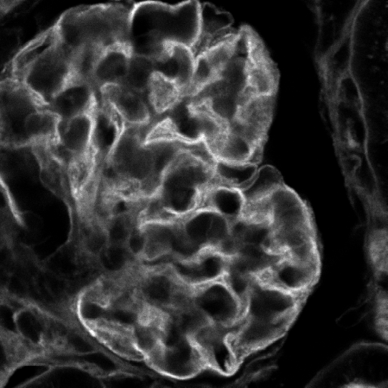
Figure 1. Up: A map of 2x3 low resolution images (20x objective, zoom=1) tiling a large region of the sample, the detected glomeruli appear as yellow crosses after the automatic detection. Down-left: A montage of squared regions cropped around the detected positions. Down-right: The first high resolution images acquired during the secondary scan.
This sequence of operations is achieved by an ImageJ macro (a program running on the ImageJ platform) which enables an image processing workstation to take control over a Leica SP5 confocal microscope through the Leica CAM interface (from the Leica Matrix HCS-A add-on module). The macro accesses the images of the scans and takes advantage from the extensive image analysis functionalities of ImageJ to find the structures of interest. The same macro can be applied to virtually any fixed sample, the only part of the code that should be modified according to a specific application is the detection of the targets.

1.2) System configuration
The system has been developed for the Leica SP5 confocal microscope. It requires the Leica Matrix HCS-A add-on module and the Leica CAM (Computer Assisted Microscopy) interface of the LAS AF software. In the standard setup (figure 1) both the microscope and the image processing workstations are connected to the same local network. The interaction is enabled by the CAM protocol. The image processing workstation accesses the images from a network shared folder. It is also possible to have ImageJ running on the microscope workstation since the analysis is performed offline, after the primary scan finishes, and hence cannot interfere with the scan.
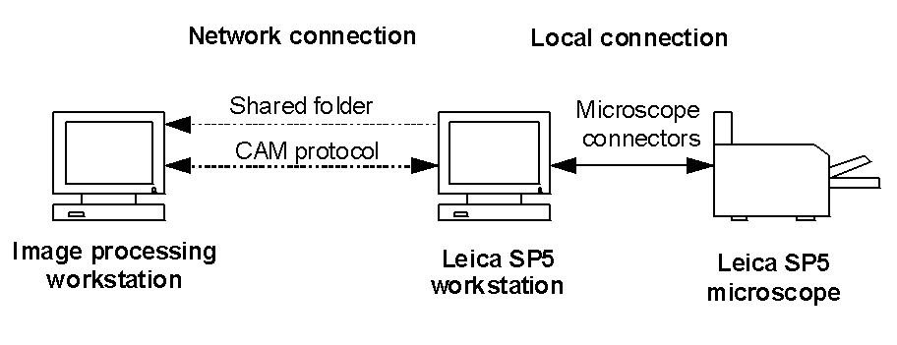
Figure 2. Physical and functional connections between the microscope, the microscope workstation and the image processing workstation.
1.3) LAS AF, ImageJ and the CAM interface
The primary and secondary scans have to be set up in the matrix module of the LAS AF; they are both defined as a job (low and high resolution jobs) with associated settings. The grid of the primary scan should tile the scan region and is defined inside this module by setting a regular grid of wells with the screener option multiple regular matrices. The grid location is adjusted by the user by recording its upper left corner and the low resolution job is then assigned to it. After the autofocus map has been generated the dual scan is ready to be launched by running the ImageJ macro.
The communication between ImageJ and the software is performed by the ImageJ macro by sending and receiving CAM commands through a bi-directional TCP socket. In this process the microscope workstation acts as a server and ImageJ is seen as a client. For the communication the macro requires a specific ImageJ plugin called LASAFclient_.jar that is not available in the common ImageJ bundles; this plugin is able to send and receive CAM commands and it should be copied to the ImageJ plugins folder.
1.4) The macro performing the dual-scan
The macro RegionsScanner.ijm is written in a modular way so that the image analysis function (in charge of the targets detection) can easily be adapted to virtually any application. The only requirement is that the function returns an ImageJ selection made of several points of interest on the low resolution map of the primary scan. The macro is in charge of launching the scans, accessing, processing and presenting the images to the user. User interactions, for instance to refine the selection of the detected targets, is also handled by the macro. The images of the secondary scan are exported as OME TIFF files with explicit reference to the well, z plane and channel in the file naming. The figure 3 illustrates all the actions performed by the user and the macro during a dual scan experiment. A detailed description of the way to configure the matrix module for a dual scan can be found in the document "Manual for ImageJ CAM Intelligent Scan".
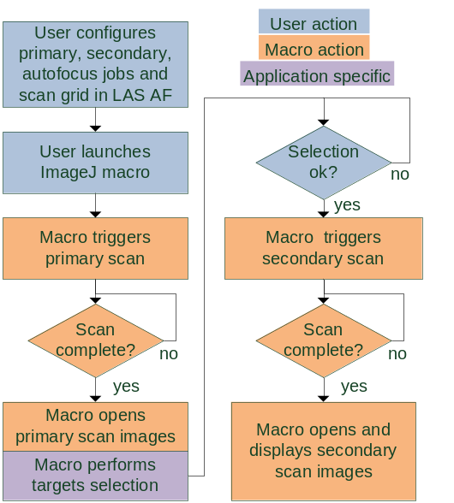
Figure 3. Actions performed by the user and the macro during a dual scan experiment.

1.5) Target detection and example applications
Only a basic knowledge of ImageJ and its macro language is required to adapt the macro to a specific target detection. If the sequence of operations is really simple it can even be translated to the ImageJ macro language without having to write a single line of code by the macro recorder, a tool recording the operations performed by the user and translating them to macro code. This sequence of operations can then be copied in an empty function of the analysis functions file FixedCAMAnalysisFunctions.ijm that is loaded by the RegionScanner macro and must be located in the macro folder of ImageJ. The analysis functions present in the file are automatically registered and can be chosen by the user from a drop down menu of the initial dialog box.
A possible sequence of operations is illustrated in figure 4 for the detection of mitotic cells from a DAPI staining. The upper leftmost image is a cropped area of the low resolution map (primary scan). The image is in 8-bit format. The sequence of ImageJ operations is as follow:
(1) Apply a "median filter" with radius 2 pixels.
(2) "Remove outliers" (radius=4, threshold=35).
(3) "Subtract" image (2) from image (1).
(4) "Threshold" the image considering all non zero pixel as object (black).
(5) "Analyze particles" and select the particles with an area greater or equal than 12 pixels.

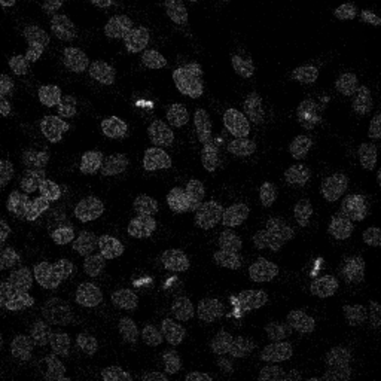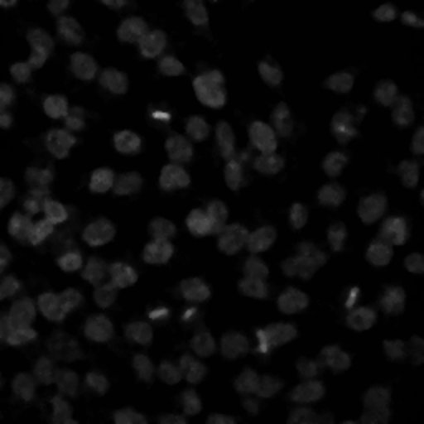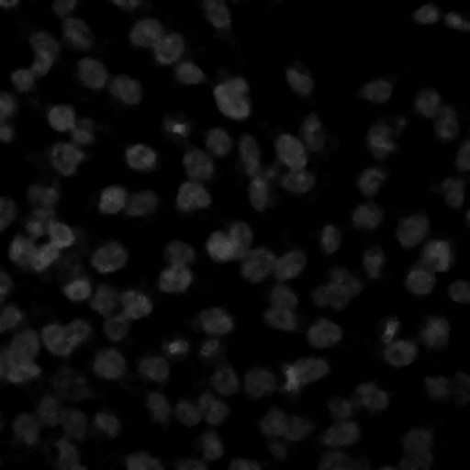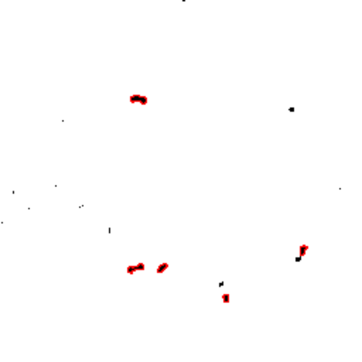
Figure 4. Detection of the mitotic cells from DAPI staining Images are indexed from upper left image to lower right image. (1) Original image, (2) median filtering (radius=2 pixels), (3) remove outliers (radius = 4 pixels, threshold = 35), (4) result of (3) subtracted to result of (2), (5) thresholding all non zero pixel, (6) Selection of the particle with area greater or equal than 12 pixels (the borders of the selected particles are highlighted in red).

The same sequence of ImageJ operations translated to an ImageJ macro function:
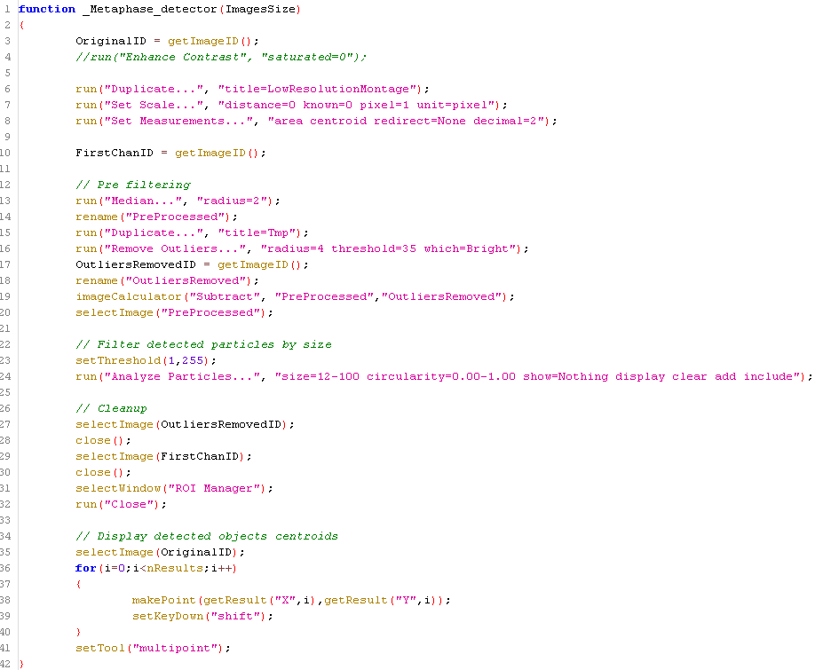
The input argument is a 2 elements array holding the width and the height of the images forming the low resolution map (as set in the low resolution job).
The first section of the function only duplicates the active image (the low resolution map is active when the function is called) and sets the image spatial calibration to be in pixel. It also sets the measurements to be area and centroid position of the particles.
The second and third sections correspond to the functional part of the function and perform the sequence of operations previously described. The temporary images are then closed and a point selection is created at the position of each particle centroid (the targets).
The function name must start by an underscore for a correct parsing of the file and registration of the function by the RegionScanner macro.
2) Sequential analysis, application to Cytoo chips analysis

2.1) Sequential analysis
For some specific samples or if the number of fields to acquire is very high it might not be a good strategy to tile the whole sample. A macro of the suite called RegionsScanner_XYBlocks.ijm allows to analyze some (or all) the field of views by grouping them in blocks (wells) organized on a regular grid. In this case only the images from a single well are opened at once to perform the detection of the targets. For this mode of operation the sub-positions of each wells correspond to the X/Y positions of the well subdivision in the matrix software.
2.2) Cytoo chips
Regular Cytoo chips are organized as 12x12 blocks each made of a regular 12x12 or 9x9 grid of fluorescently stained fibronectin patterns. The patterns are either identical all over the chip or can have various shapes and sizes (starter chip), the blocks are always 1300 µm squares. The specification of a starter chip is presented in figure 5.
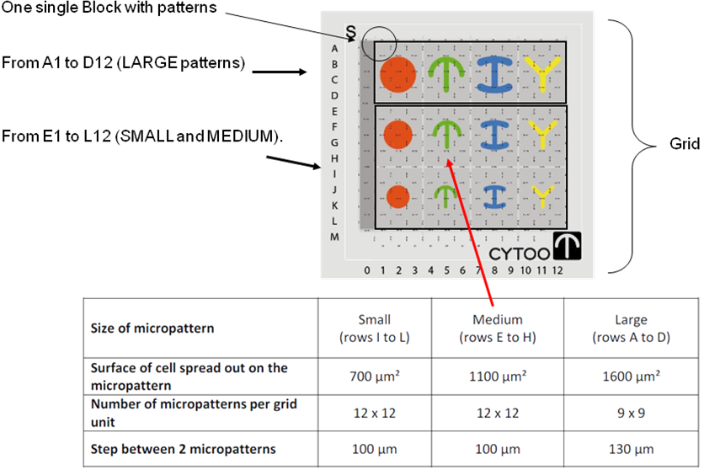
Figure 5. Specification a Cytoo starter chip.

2.3) Dual-scan principle
The primary scan of a Cytoo chip is performed by the sequential analysis macro, 2x2 views per well are used to tile each of the Cytoo blocks. The analysis function (stored this time in the file FixedCAMMultipleScansAnalysisFunctions.ijm) detects the Cytoo patterns in the pattern channel and computes the occupancy (number of cells) of each pattern by analyzing the images of the DAPI channel.
In our application high resolution images of the isolated cells (one a pattern) were acquired during the secondary scan (typically an overnight scan without user interaction). The analysis function can be easily extended to, for instance, only select the cells that are well spread on the patterns (by analyzing a third channel with a properly chosen marker of the cytoplasm).
An additional macro (not in the suite) is capable to build ScoreMap (figure 6) from the previous analysis.
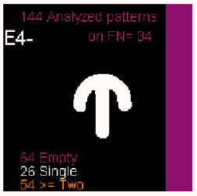

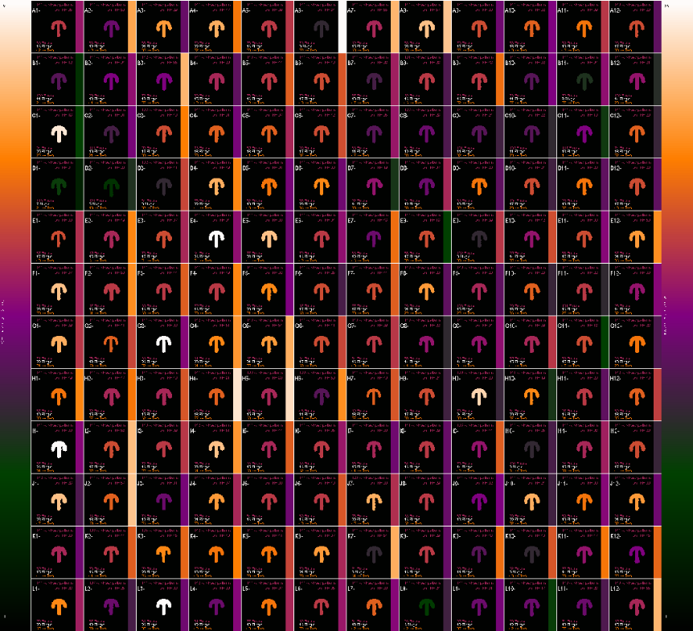
Figure 6. The ScoreMap of a medium crossbow pattern Cytoo chip. In each of the 12x12 blocks the number of patterns that could be analyzed, the number of empty patterns, the number of patterns with a single cell and the number of patterns with multiple cells are specified. The field "on FN" reports the number of cells that could be detected in the control band of each block. The patterns drawn in the blocks corresponds to the geometry that has actually been identified by the macro and they are color coded according to the number of isolated cells (left color bar). The local seeding density is color coded on the right side of the blocks, it is assumed directly proportional to the number of cells that have been detected on the control band.
2.4) Scan setup
It is extremely important that the three bases (figure 7): Cytoo chip grid, stage axes and field of view axes are well aligned. If the microscope camera/scanning head is not moved with respect to the stage the correct rotation of the field of view can be determined once for all (axial tilt). The Cytoo grid can be aligned by recording the position of the center of a specific pattern and iteratively rotating the stage adaptor to get the minimal position drift when moving from block to block. An easier option is to use the matrix angle option which allows to compensate for a tilt between the stage and the sample by recording two reference positions. The fluorescent patterns and DAPI channels must be acquired during the primary scan.
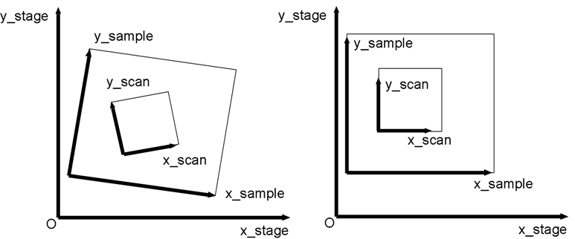
Figure 7. The three reference basis when scanning a Cytoo chip.

3) Extension: Micro-manager bridge and intelligent live scan
3.1) Micro-manager bridge (see poster)
The bridge is actually not limited to Leica microscopes: we wrote two Beanshell scripts for Micro-manager that emulates the CAM interface (to date only few commands are supported: the ones required by the ImageJ-CAM bridge). The scripts are called MM_CAMEmulation_ROI_AF.bsh and MM_CAMEmulation_XYBlocks.bsh and correspond to tiling and block sequential modes of the previous mode of operation.
Using the scripts any motorized microscope which is supported by Micro-manager can be used for intelligent scanning. For a widefield microscope the image resolution can be varied by either relying on camera binning or switching the objective between the scans (for this last option care must then be taken to ensure parfocality and paraxiality, optionally these defects can be compensated for). It is very important that the tilt of the field of view be manually corrected (rotating the camera) as there is so far no software compensation implemented.
To date the only autofocus procedure which is supported relies on manual adjustment and 3 corner points interpolation but we are planning on including a true software based autofocus.
Note: The Micro-manager - ImageJ macro socket communication could be avoided by directly writing a specific Micro-Manager plugin that would load the analysis function.
3.2) Tiled intelligent live scan (see poster)
The macro LiveTracker_search_and_shoot.ijm basically performs looped primary scans with a user defined repetition time. The changed in the low resolution map during the last 2 or 3 time points are analyzed and in case an event of interest is detected (e.g. cell mitosis), a secondary scan is triggered centered on the position of this event. This secondary scan is itself a time-lapse with a specific frame rate and runtime length. When the secondary scan finishes the primary scan resumes until another event is detected. A specific event detection function defined in the file LiveCAMAnalysisFunctions.ijm is in charge of detecting the potential events of interest and returning a point selection centered on the most likely event. When called the analysis function expects that a stack with 3 slices is active with the last slice corresponding to the low resolution map of the current time point and the first two slices corresponding to the low resolution maps of the two previous time points.
3.3) Block based intelligent live scan (see poster)
As for fixed intelligent scan there is an extension to perform the monitoring of several independent blocks (each made of a fixed number of field of views). The wells can be manually defined anywhere in the sample by using the last option of the matrix wizard. The respective names of the macros are: LiveTracker_search_and_shoot_Positions.ijm and LiveCAMAnalysisFunctionsPositions.ijm.
4) Work in progress
4.1) Parallel tracks mode
When the first low resolution map has been acquired it is presented to the user who can click on up to N particles of interest that will be tracked. The subsequent low resolution scans are fast since only acquired for the positions containing the particles to be tracked (these positions are updated to accommodate the particles movements). At each time point and after the primary scan finishes N slots are allocated to a single time frame of a secondary scan. To limit bleaching these secondary scans are only enabled if a specific event has been detected in the low resolution scan (once triggered the secondary scan associated to a given particle will remain active for a fixed number of time frames and cannot be re-triggered once finished). In this mode the repetition period for the primary and secondary scans is the same.
4.2) SmartMosaic3D
This macro will be very similar to the RegionsScanner macro, the main difference is that the low resolution map is now 3D (no maximum intensity projection). A 3D reconstruction of the low resolution map is presented to the user that can click on point of interests that will be used as seeds for automatic segmentation of the objects (e.g. neurons or blood vessels). The secondary scan is generated as several overlapping stacks which are tightly mosaicing the segmented 3D objects.

List of applications (so far)
See poster
+ FISH spot detection in human spermatozoids (special macro handling a scan with 4 different fluorescent channels)

